# Report 4

**team members：**

白明松 16301059

**technical features applied：**

Use Case Scenario:

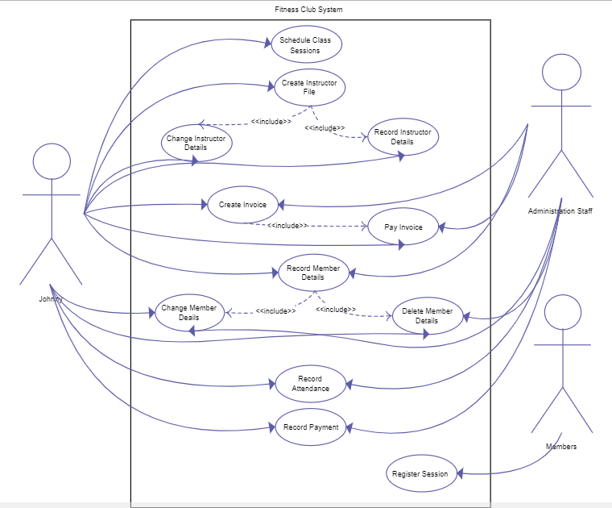

As per requirements from our client, users hope the app will enable them to query the private trainer information as well as the training material offline.

